**Phonepe Integration**

# Plugin Integration:

## Woocommerce Plugin:

Please find the documentation for Woocommerce Plugin: <https://developer.phonepe.com/v1/docs/woocommerce-plugin-1>

**Test credentials:**

**MID:** PHONEPEPGUAT

**Key Index:** 1

**Key:** c817ffaf-8471-48b5-a7e2-a27e5b7efbd3

Please install the Phonepe pre-prod app for testing purposes:<https://developer.phonepe.com/v1/docs/setting-up-test-account>

## Opencart Plugin:

Please find the documentation for Opencart Plugin: <https://developer.phonepe.com/v1/docs/opencart-plugin-1>

Test credentials:

**MID:** PHONEPEPGUAT

**Key Index:** 1

**Key:** c817ffaf-8471-48b5-a7e2-a27e5b7efbd3

Please install the Phonepe pre-prod app for testing purposes:<https://developer.phonepe.com/v1/docs/setting-up-test-account>

# Website Integration:

## **Standard Checkout(Website/Pay Page Integration):**

(When merchant integrates Pay page with all instruments by default on the website)

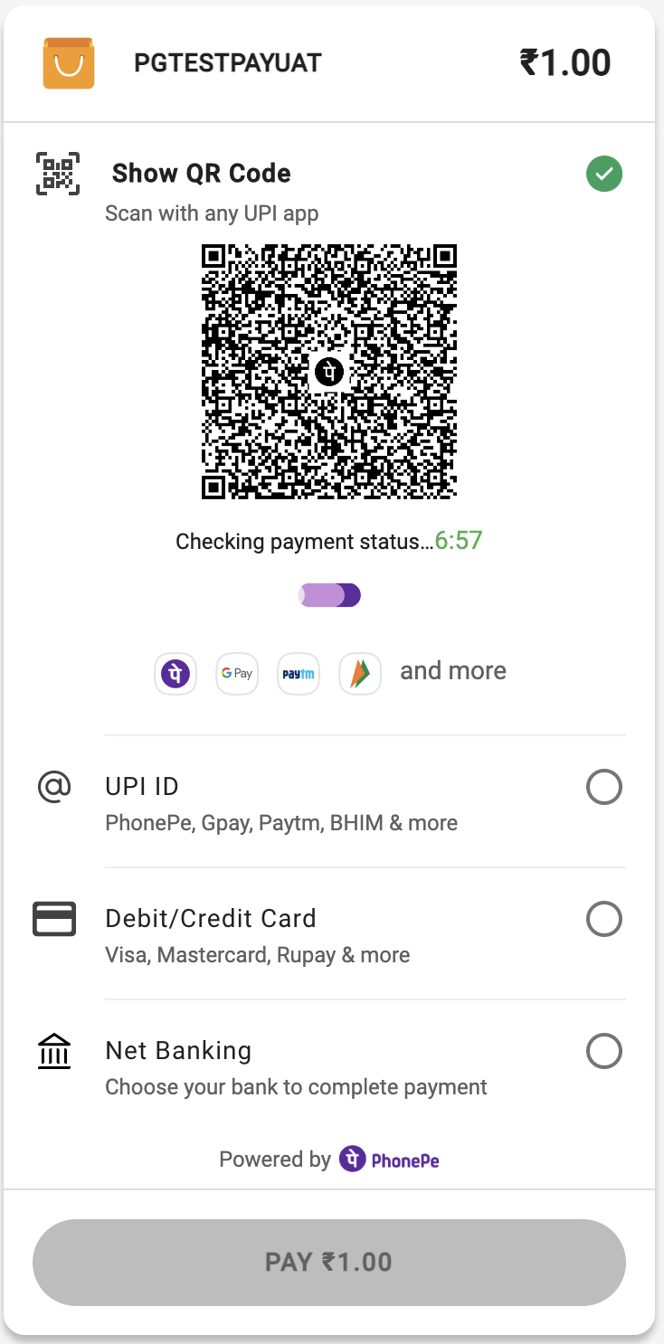

**Payment Initiation**

Pay API: [https://developer.phonepe.com/v1/reference/pay-api#pay-request-for-web-flow](https://developer.phonepe.com/v1/reference/pay-api" \l "pay-request-for-web-flow)

Response Authorization

Check Payment Status -<https://developer.phonepe.com/v1/reference/check-status-api>

Server-to-Server Response -<https://developer.phonepe.com/v1/reference/server-to-server-callback-4>

Refund Flow

Refund API -<https://developer.phonepe.com/v1/reference/refund-6>

Refund Status API -<https://developer.phonepe.com/v1/reference/check-status-api>

**Test credentials:**

**MID:** PHONEPEPGUAT

**Key Index:** 1

**Key:** c817ffaf-8471-48b5-a7e2-a27e5b7efbd3

**Test card details:**

"card_number": "4622943126146407",

"card_type": "DEBIT_CARD",

"card_issuer": "VISA",

"expiry_month": 12,

"expiry_year": 2023,

"CVV": "936",

Bank Page OTP: 123456

Please use UAT Simulator for testing:<https://developer.phonepe.com/v1/docs/uat-simulator-1>

## **Custom Checkout:**

(When merchants wish to integrate PhonePe at instrument levels like Card, UPI, QR, Collect, or Netbanking)

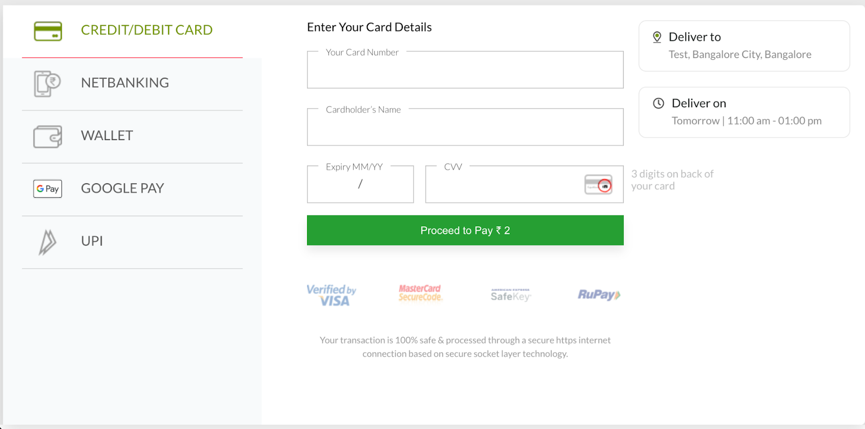

### **UPI Open Intent:**

(This instrument is generally implemented for Android Application integration with Phonepe)

**Payment Initiation**

[https://developer.phonepe.com/v1/reference/pay-api#pay-request-for-upi-open-intent-flow](https://developer.phonepe.com/v1/reference/pay-api" \l "pay-request-for-upi-open-intent-flow)

**Response Authorization**

Check Payment Status -<https://developer.phonepe.com/v1/reference/check-status-api>

Server-to-Server Response -<https://developer.phonepe.com/v1/reference/server-to-server-callback-4>

**Refund Flow**

Refund API -<https://developer.phonepe.com/v1/reference/refund-6>

Refund Status API -<https://developer.phonepe.com/v1/reference/check-status-api>

**Test credentials:**

**MID:** PHONEPEPGUAT

**Key Index:** 1

**Key:** c817ffaf-8471-48b5-a7e2-a27e5b7efbd3

Please use UAT Simulator for testing:<https://developer.phonepe.com/v1/docs/uat-simulator-1>

### **UPI Collect:**

(This Payment instrument can be implemented for both website and Android Applications)

**VPA validation:**

https://developer.phonepe.com/v1/reference/vpa-validate-api

**Payment Initiation**

https://developer.phonepe.com/v1/reference/pay-api#pay-request-for-upi-open-intent-flow

**Response Authorization**

Check Payment Status -<https://developer.phonepe.com/v1/reference/check-status-api>

Server-to-Server Response -<https://developer.phonepe.com/v1/reference/server-to-server-callback-4>

**Refund Flow**

Refund API -<https://developer.phonepe.com/v1/reference/refund-6>

Refund Status API -<https://developer.phonepe.com/v1/reference/check-status-api>

**Test credentials:**

**MID:** PHONEPEPGUAT

**Key Index:** 1

**Key:** c817ffaf-8471-48b5-a7e2-a27e5b7efbd3

Please use UAT Simulator for testing:<https://developer.phonepe.com/v1/docs/uat-simulator-1>

### **UPI QR:**

(This Payment instrument can be implemented only on the website)

**Payment Initiation**

https://developer.phonepe.com/v1/reference/pay-api#pay-request-for-upi-qr

**Response Authorization**

Check Payment Status -<https://developer.phonepe.com/v1/reference/check-status-api>

Server-to-Server Response -<https://developer.phonepe.com/v1/reference/server-to-server-callback-4>

**Refund Flow**

Refund API -<https://developer.phonepe.com/v1/reference/refund-6>

Refund Status API -<https://developer.phonepe.com/v1/reference/check-status-api>

**Test credentials:**

**MID:** PHONEPEPGUAT

**Key Index:** 1

**Key:** c817ffaf-8471-48b5-a7e2-a27e5b7efbd3

Please use UAT Simulator for testing:<https://developer.phonepe.com/v1/docs/uat-simulator-1>

### **Card Flow:**

(This Payment instrument can be implemented for both website and Android Applications)

**Payment Initiation**

https://developer.phonepe.com/v1/reference/pay-api#pay-request-for-card-flow

**Response Authorization**

Check Payment Status -<https://developer.phonepe.com/v1/reference/check-status-api>

Server-to-Server Response -<https://developer.phonepe.com/v1/reference/server-to-server-callback-4>

**Refund Flow**

Refund API -<https://developer.phonepe.com/v1/reference/refund-6>

Refund Status API -<https://developer.phonepe.com/v1/reference/check-status-api>

**Test credentials:**

**MID:** PHONEPEPGUAT

**Key Index:** 1

**Key:** c817ffaf-8471-48b5-a7e2-a27e5b7efbd3

**Test card details:**

"card_number": "4622943126146407",

"card_type": "DEBIT_CARD",

"card_issuer": "VISA",

"expiry_month": 12,

"expiry_year": 2023,

"CVV": "936",

Bank Page OTP: 123456

Please use UAT Simulator for testing:<https://developer.phonepe.com/v1/docs/uat-simulator-1>

### **Netbanking Flow:**

(This Payment instrument can be implemented for both website and Android Applications)

**Get Available bank:**

https://developer.phonepe.com/v1/reference/payment-options-api

**Payment Initiation**

https://developer.phonepe.com/v1/reference/pay-api#pay-request-for-net-banking

**Response Authorization**

Check Payment Status -<https://developer.phonepe.com/v1/reference/check-status-api>

Server-to-Server Response -<https://developer.phonepe.com/v1/reference/server-to-server-callback-4>

**Refund Flow**

Refund API -<https://developer.phonepe.com/v1/reference/refund-6>

Refund Status API -<https://developer.phonepe.com/v1/reference/check-status-api>

**Test credentials:**

**MID:** PHONEPEPGUAT

**Key Index:** 1

**Key:** c817ffaf-8471-48b5-a7e2-a27e5b7efbd3

**Test Netbanking details:**

**Username:** Test

**Password:** Test

Please use UAT Simulator for testing:<https://developer.phonepe.com/v1/docs/uat-simulator-1>

# Android Integration:

### **Android Intent SDK**

(This is for the native Android Platform)

**Payment Initiation**

Android PG SDK - <https://developer.phonepe.com/v1/docs/android-pg-sdk-integration>

Response Authorization

Check Payment Status -<https://developer.phonepe.com/v1/reference/check-status-api>

Server-to-Server Response -<https://developer.phonepe.com/v1/reference/server-to-server-callback-4>

Refund Flow

Refund API -<https://developer.phonepe.com/v1/reference/refund-6>

Refund Status API -<https://developer.phonepe.com/v1/reference/check-status-api>

Test credentials:

**MID:** PHONEPEPGUAT

**Key Index:** 1

**Key:** c817ffaf-8471-48b5-a7e2-a27e5b7efbd3

Please use UAT Simulator for testing:<https://developer.phonepe.com/v1/docs/uat-simulator-1>

### **Android SDKLess**

(This is for Hybrid integrations like IONIS, REACT Native, Node JS, etc..)

**Payment Initiation**

Android PG SDKLess - https://developer.phonepe.com/v1/docs/android-pg-sdkless-integration

**Response Authorization**

Check Payment Status -<https://developer.phonepe.com/v1/reference/check-status-api>

Server-to-Server Response -<https://developer.phonepe.com/v1/reference/server-to-server-callback-4>

**Refund Flow**

Refund API -<https://developer.phonepe.com/v1/reference/refund-6>

Refund Status API -<https://developer.phonepe.com/v1/reference/check-status-api>

**Test credentials:**

**MID:** PHONEPEPGUAT

**Key Index:** 1

**Key:** c817ffaf-8471-48b5-a7e2-a27e5b7efbd3

Please use UAT Simulator for testing:<https://developer.phonepe.com/v1/docs/uat-simulator-1>

# IOS Integration:

## **IOS Intent SDK**

**Payment Initiation**

IOS PG SDK - <https://developer.phonepe.com/v1/docs/ios-pg-sdk-integration>

Response Authorization

Check Payment Status -<https://developer.phonepe.com/v1/reference/check-status-api>

Server-to-Server Response -<https://developer.phonepe.com/v1/reference/server-to-server-callback-4>

Refund Flow

Refund API -<https://developer.phonepe.com/v1/reference/refund-6>

Refund Status API -<https://developer.phonepe.com/v1/reference/check-status-api>

Test credentials:

**MID:** PHONEPEPGUAT

**Key Index:** 1

**Key:** c817ffaf-8471-48b5-a7e2-a27e5b7efbd3

Please use UAT Simulator for testing:<https://developer.phonepe.com/v1/docs/uat-simulator-1>

## **IOS SDKLess**

**Payment Initiation**

IOS PG SDKLess - <https://developer.phonepe.com/v1/docs/ios-pg-sdkless-integration>

Response Authorization

Check Payment Status -<https://developer.phonepe.com/v1/reference/check-status-api>

Server-to-Server Response -<https://developer.phonepe.com/v1/reference/server-to-server-callback-4>

Refund Flow

Refund API -<https://developer.phonepe.com/v1/reference/refund-6>

Refund Status API -<https://developer.phonepe.com/v1/reference/check-status-api>

Test credentials:

**MID:** PHONEPEPGUAT

**Key Index:** 1

**Key:** c817ffaf-8471-48b5-a7e2-a27e5b7efbd3

Please use UAT Simulator for testing:<https://developer.phonepe.com/v1/docs/uat-simulator-1>